Partners VPN Instructions

MindShift has a SSLVPN solution for remote file access. Their upgraded version of the SSLVPN will also support Macs and 64-bit operating systems. To access files through VPN:

Here are some basic instructions

- Go to http://vpn.mindshift.com
- Follow the instructions that come up (you will only have to do this the first time to access vpn.mindshift.com)
- You may have to reboot - some users require a reboot and others not require a reboot.

Login prompt:

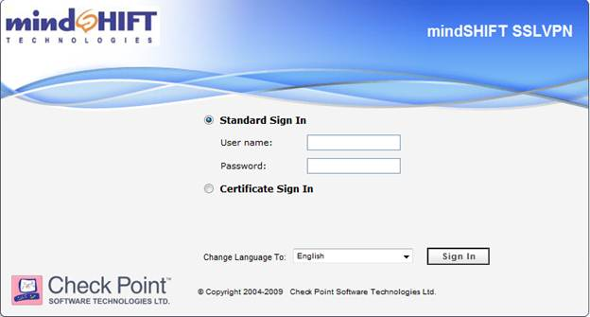

You use your network login here, not your email address (first.last@partners.net)

You will get a “Do you want to install this software?” pop-up every time you log in. The following steps allow you to keep the pop-up from reoccurring.

When this window appears, Click the arrow next to More options.

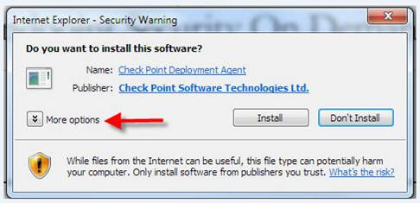

Select Always install software from “Check Point Software Technologies Ltd.” (the first option) and then Click Install.

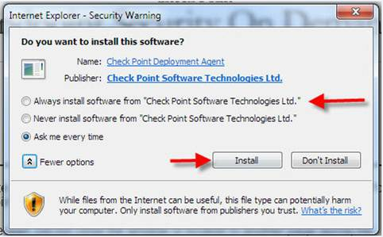

Mapping your Network Drives
These steps will connect you to the VPN. Once connected, save the attached file to your computer. It is currently named “PAR network drives.bat.txt” – you will need to remove the .txt extension so that the name is “PAR network drives.bat”. (this renaming is necessary as many email programs don’t allow .bat files to be sent as attachments). This should make it a live batch file ready to execute – double click on this file and your Network drives will be mapped on your computer.

